The Road to World War II

In this module you will learn:

- FIVE new words
- Hitler’s THREE aims in his Foreign Policy.
- SIX steps to war.
- SEVEN key dates in the Sudetenland crisis.
- EIGHT views of appeasement.
- NINETEEN reasons Chamberlain appeased Hitler [A–S].
- THREE reasons British policy towards Hitler changed, 1938–1939.
- FOUR reasons Anglo-Soviet talks failed [SCAB].
- FOUR reasons Russia allied itself to Germany in 1939 [THUG]

You should do the following work:

r A list of exam questions on the Causes of WWII.
r A Causes of WWII reading list.
r A video worksheet: ‘Hitler goes to war’.
r Written notes on ‘Hitler’s Steps to War’.
r A video worksheet: ‘Why Appeasement?’.
r An exam answer: ‘Why did Britain & France appease Germany?’
r An exam answer: ‘Why did British foreign policy change towards Germany in the year after Munich?’
r A notes sheet: ‘Why did Anglo-Soviet talks fail? [SCAB] and ‘Why did the Nazi-Soviet Pact happen? [THUG].
r A revision sheet: The Causes of WWII.

Have you read:
❒ N deMarco and R Radway, The Twentieth Century.
❒ T Rea and J Wright, International Relations.
❒ Christopher Culpin, Making History..

New Words  Anschluss: a German word meaning ‘link’.  Lebensraum: A German word meaning ‘living space’.  Source A  The Versailles Treaty is worthless. 60 million German hearts and minds are on fire with anger and shame. They will cry out ‘We want war!’  Mein Kampf (a book written by Hitler in 1924).  Source B  It will be the duty of German foreign policy to get large spaces to feed and house the growing population of Germany. Destiny points us towards Russia.  Hitler, Mein Kampf (1924).  Source C  The menace of Russia hangs over Germany. All our strength is needed to rescue our nation from this international snake.  Hitler, Mein Kampf (1924) |  | The League of Nations’ Failures  When you studied the League of Nations, you learned that it had two great failures in the 1930s:  - Manchuria (1931)  - Abyssinia (1935)  A much greatest disaster for the League, however (although pupils usually forget to mention it in their essays!), was:  - The failure to stop Hitler in Europe (1933–39)  This booklet studies this, the League’s greatest failure.  Hitler’s Aims  In 1935, the historian HAL Fisher wrote that ‘a country which is determined to have a war can always have it.’ Hitler was determined to destroy the League, and it is doubtful if anything could have saved it.  Hitler had three aims:  - To abolish the Treaty of Versailles  The Germans hated it, especially:  - Tiny armed forces,  - Rhineland demilitarised,  - Anschluss with Austria forbidden,  - Germans forced to live in Czechoslovakia (the Sudetenland) and Poland (including Danzig).  The Treaty was a constant reminder to the Germans of their humiliation in World War I. Hitler did not believe that the German army had lost the war, and he was determined to make Germany great again.  - To expand German territory  The German population was growing. Hitler said that the German nation needed more Lebensraum (‘living space’). He was determined to get Lebensraum by conquering land in eastern Europe.  - To defeat Communism  The Nazis were Fascists: the exact opposite of the Communists who ruled Russia. Hitler was determined to destroy Communism, and this meant a war with Russia
Six Steps to War  1 CONSCRIPTION & RE-ARMAMENT  Hitler began to build up his armed forces. In 1935 he introduced conscription (calling up men to the army). This broke the Treaty of Versailles, but Britain and France let him get away with it.  2 RHINELAND  Hitler invaded the Rhineland on 7 March 1936. This broke the Treaty of Versailles. It was a bluff – the German army had only 22,000 soldiers and had orders to retreat if they met any resistance. But once again, Britain and France did nothing.  3 AUSTRIA  In 1938, Hitler took over Austria. First, Hitler encouraged the Austrian Nazis to demand union with Germany. Then Hitler invaded Austria. This broke the Treaty of Versailles, but Britain and France did nothing.  4 MUNICH  In 1938, Hitler tried to take over the Sudetenland. First, Hitler encouraged the Sudeten Nazis to demand union with Germany. Then, Hitler made plans to invade Czechoslovakia.  Neville Chamberlain appeased Hitler. At Munich, on 29 September 1938, Britain and France gave Hitler the Sudetenland.  5 CZECHOSLOVAKIA  In March 1939, Hitler’s troops marched into the rest of Czechoslovakia. This, for most British people, was the time when they realised that the only thing that would stop Hitler was a war.  6 USSR/NAZI PACT & POLAND  In 1939, Hitler tried to take over Poland. First, the Germans in Danzig demanded union with Germany. Then, Hitler threatened war.  Chamberlain promised the Poles that Britain would support them if Germany attacked Poland.  In August 1939, Hitler made a secret treaty with Russia. He thought this would stop Britain & France helping Poland.  On 1 September 1939, Hitler invaded Poland.  On 3 September 1939, Chamberlain declared war on Germany. |  |  |  | 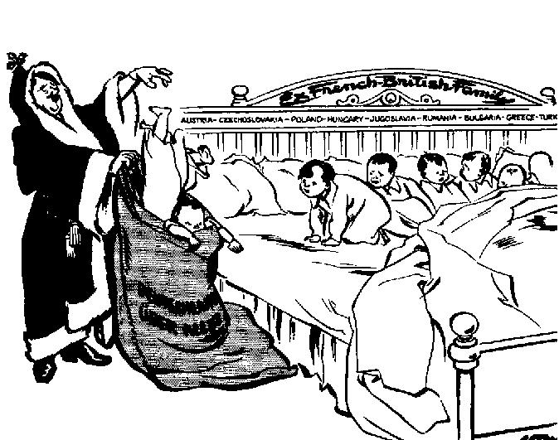  ⬆ Source D  This cartoon from 1938 shows Hitler as Santa, popping into his sack, one-by-one, little countries – who had got into bed with the ‘French-British family’. His sack says: Deutschland Uber Alles (‘Germany over all’).  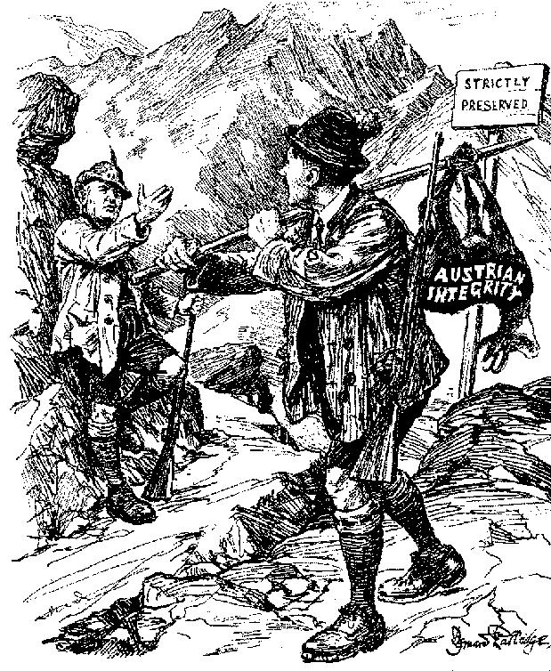  ⬆ Source E  This cartoon from 1938 shows Hitler as a poacher, stealing Austria. Mussolini is shown as a game-keeper. ‘I never heard a shot, Adolf’’, he is saying.  Tasks  Match Hitler’s Aims 1–3 with Sources A–C from Mein Kampf.  What is the cartoonist of Source D saying about Hitler?  What is the cartoonist of Source E saying about Britain?  Discuss in a group: How much was Hitler to blame for World War II?

New Words  Appeasement: giving way to a bully.  Reich: a German word meaning ‘empire’.  Source A  Give thanks to your God. Your children are safe. Peace is a victory for all mankind. If we must have a victor, let us choose Mr Chamberlain.  The Daily Express, 1938.  Source B  It is a total defeat. Czechoslovakia will be swallowed up by the Nazis. And do not suppose that this is the end. This is only the beginning.  Churchill, speaking about the Munich Agreement in 1938.  Tasks  Divide Sources A–D into those which supported the policy of appeasement, and those which criticised it  Which of Sources A–D suggest Hitler would carry on as long as people kept appeasing him.  Write a paragraph about each of Sources C and D, explaining the cartoon’s meaning. |  | Appeasement  Nowadays, many people criticise Chamberlain for appeasing Hitler.  In the 1930s, there were some people – most notably Winston Churchill – who opposed his policy.  But at the time, most people thoroughly agreed with Chamberlain, and praised him.  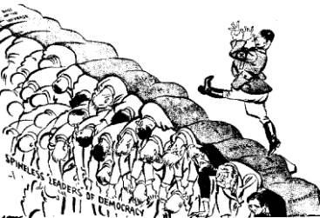  ⬆ Source C  A British cartoon of 1936. Hitler goose-steps across the ‘spineless leaders of democracy’. The first three steps are labelled ‘Rearmament’, ‘Rhineland’ and ‘Danzig’.  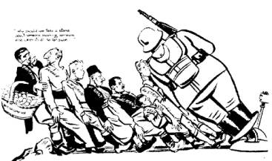  ⬆ Source D  A British cartoon of 1938 shows Germany crushing Austria. Next in line is Czechoslovakia. At the back, Britain says to France: ‘Why should we take a stand about someone pushing someone else when it’s all so far away’.

Appeasement in Action  Before 1938, Britain had already given way to Hitler on a number of occasions, but it was the events of the Sudeten crisis which showed appeasement in action – trying to buy off Hitler by giving way to his demands.  On 11 March 1938, Hitler invaded Austria. It was clear he wanted to do the same in the Sudetenland.  On 7 September 1938, the German Sudeten Party demanded union with Germany.  - There were riots.  - German newsreels showed ‘evidence’ of Czech ‘atrocities’ against the Sudeten Germans.  - Hitler threatened to support the Sudeten Germans with military force.  Then Chamberlain intervened.  - Chamberlain met Hitler at Berchtesgaden (15 Sept.).  - Hitler promised him that this was the ‘last problem to be solved’.  - Chamberlain decided Hitler was ‘a man who can be relied upon’.  - He persuaded the Czechs to hand over the Sudetenland.  - Chamberlain met Hitler at Bad Godesberg (22 Sept.)  - Hitler made more demands.  - At first Chamberlain refused, but then he decided that Czechoslovakia was not one of the ‘great issues’ which justified war, but just ‘a quarrel in a far-away country between people of whom we know nothing’.  - Britain and France met Hitler again at Munich  (29 September).  - They gave the Sudetenland to Germany.  On 30 September, Chamberlain returned to England with his famous piece of paper. ‘I believe it is peace for our time’, he told the cheering crowd.  Czechoslovakia was not even invited to the talks. The Czechs were free to fight if they wished, but they had no support. They chose not to fight.  On 1 October 1938, Hitler marched unopposed into the Sudetenland. He said that it was the start of a 1000-year German Reich (empire). |  | Source E  Historians have said that appeasement:  - let Hitler grow stronger.  - gave Britain time to re-arm.  - humiliated Britain – no country in central Europe ever trusted Britain again.  - abandoned millions of people to the Nazis.  - caused the war, by encouraging Hitler to think he could do anything.  - gave Britain the morale high ground – when war came, Britons knew they had done everything possible to keep the peace.  - would never have stopped Hitler, who was determined to go to war.  - was a fine attempt to prevent the deaths of millions of people in a war.  Source F  Thus we begin our march into the great German future.  Hitler, speaking after the Munich Agreement in 1938.  Tasks  You are a journalist who does not agree with appeasement. For the 7 key dates, write an imaginary diary, emphasising how Chamberlain appeased Hitler throughout.  Study Source E. Divide the statements into those which justify appeasement, and those which criticise it.  Discuss in a group which opinion you find most convincing – was appeasement a disaster, or a godsend?

Why Chamberlain Appeased Hitler – 19 Essay Ideas

1. Approval
Many Conservatives liked and supported Hitler’s strong, right-wing government.
2. Britain was weak
Britain’s small army was too weak to go to war in 1938; needed time to re-arm.
3. Communism
Many Britons saw Hitler as a defence against Russian Communism.
4. Democracy
The critical factor. Chamberlain was not a dictator with the right to start a war if he pleased. He could not go to war without the support of the people – and until 1939 most people wanted peace, almost at any price.
5. Empire
Britain could not defend her empire AND fight a war in Euorpe.
6. France
Did not want war; and Britain could not fight Germany alone.
7. German propaganda
claimed that Germans in the Sudetenland and Poland were being mistreated.
8. Home
The Labour Party wanted to spend on housing and social care, not re-armament.
9. Ist World War
Chamberlain & many others remembered the slaughter of the First World War.
10. Justice
The Treaty of Versailles was unfair and Hitler’s Six Steps all seemed reasonable. Other countries were conscripting to reduce unemployment.
11. Kost
Rearmament meant high taxes, which made democratic leaders unpopular.
12. League of Nations
Many people believed in the League, and that quarrels could be ended by negotiation.
13. Morality
It was RIGHT to try everything possible to keep peace: ‘War is a terrible thing, and we must make sure that it is the great issues that are involved’.
14. Neville Chamberlain
misjudged Hitler - he believed that Hitler ‘was a man who could be relied on’.
15. Out of sight, out of mind
Hitler rearmed/ persecuted the Jews etc, in secret. Western countries didn’t know.
16. Peace Movement
Many people, especially young people, wanted peace.
17. Quit
Hitler promised in 1938 that Sudetenland was the ‘last claim I have to make’.
18. Remote
Czechoslovakia was far away (none of our business?)/ Britain could not help.
19. Spanish Civil War
Guernica showed what German bombers could do to Britain if there was a war.

Task

Write an essay, ‘Why did Chamberlain appease Hitler’.

Chose the TEN most powerful reasons from the list above – each idea will take a paragraph. In each paragraph, put the Point you are making, find some Evidence to support it, then Explain how this persuaded Chamberlain he had to appease Hitler.

Your first paragraph may start:

‘The first reason why Chamberlain followed a policy of appeasement was…’.
Britain Goes To War – The End of Appeasement

28 Sept 1938 | Chamberlain signs the Munich Agreement.
3 October | Duff Cooper, First Lord of the Admiralty, resigns over Munich.
27 October | Quentin Hogg, a Chamberlain supporter, wins a by-election in Oxford, but his opponent is supported by many Conservatives (including Winston Churchill), who claim: ‘A vote for Hogg is a vote for Hitler’.
8 November | Kristallnacht – Nazis attack the German Jews. Hitler begins to persecute the Jews in Germany.
1 December | Britain sets up a ‘National Register’ of who would do what if there was a war.
3 January 1939 | The British navy is made stronger.  The RAF increases production of planes to 400 a month.
15 February | Parliament increases defence spending to £580 million a year.  A quarter of a million free air raid shelters are given to Londoners.
28 February | The Fascist ruler Franco wins the Spanish Civil War.  British MPs shout ‘Heil Chamberlain’ in Parliament.
15 March 1939 | Hitler invades Czechoslovakia; Chamberlain says it is a ‘shock to confidence’. This is the first time Hitler has attacked a non-German people. He promises to defend Poland.
29 March | The Territorial Army is doubled in numbers.
5 April | A Civil Defence Act is passed; it plans to evacuate women and children from London to the countryside.
13 April | Mussolini (the Fascist ruler of Italy) conquers Albania.
25 April | Parliament votes to spend £1,322 million on defence.
1 May | The Military Training Act introduces conscription in Britain.
19 May | Stalin suggests an alliance of France, Britain and Russia against Hitler.
22 May | Pact of Steel: Hitler and Mussolini make an alliance of support in the event of a war.
11 August | British politicians go to Moscow to make the alliance with Russia.
23 August | Russia and Germany sign a treaty, not to go to war with each other, and to attack and divide Poland between them.
26 August | Hitler sends 2000 armed Nazis to Danzig to stir up trouble, then demands Danzig and the Polish corridor.
31 August | Hitler offers to defend the British Empire if Britain lets him have Danzig and all former German colonies. Britain refuses.
31 August | The first children are evacuated from London.
1 September | Hitler invades Poland.
3 Sept 1939 | Britain declares war on Germany.

Tasks

In the list above identify:

Events in Europe which pressurised Chamberlain to change his policy of appeasement.

Events in England which pressurised Chamberlain to change his policy of appeasement.

Events which showed that Britain was preparing for war all the time

Write an essay, ‘Why did Chamberlain’s policy towards Hitler change, 1938–1939?’ Your essay will have THREE paragraphs, each with a Point, some Evidence to support it, then an Explanation of how this pressurised Chamberlain to change his policy

The FIRST paragraph will start: ‘Events in Europe put pressure on Chamberlain to abandon appeasement…’.

The SECOND paragraph will start: ‘Events in Britain put pressure on Chamberlain to abandon appeasement…’.

The THIRD paragraph will start: ‘In fact, however, there is evidence that throughout 1938 and 1939, Chamberlain was preparing for war…’.

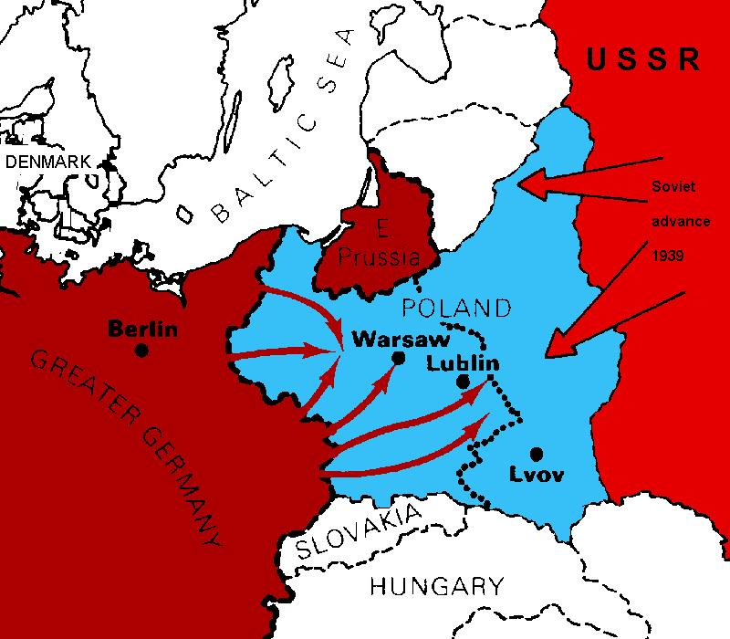  Eastern Europe in 1939.  Source A ➔  This British cartoon of 1939 shows Hitler and Stalin. What elements indicate that they are allied? What indicates that the alliance is not likely to last?  Source B ➔  This British cartoon of 1939 shows Hitler and Stalin. What elements indicate that they are allied? What indicates that the alliance is not likely to last? What do the storm clouds in the background symbolise? What does the dead figure between them represent? |  | The Nazi-Soviet Pact of 1939  On 23 August, 1939, the world was shocked when, suddenly, Russia and Germany signed a Non-aggression Pact. People would have been even more shocked if they had known at the time that, in addition, the two countries had a secret agreement to invade and divide Poland between them.  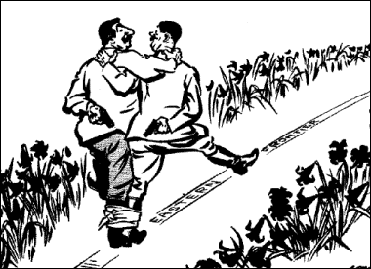  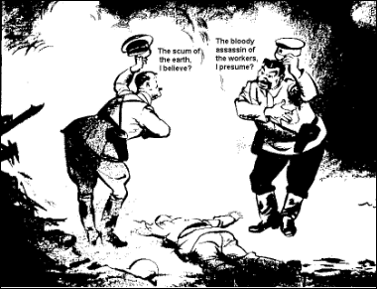

Tasks

Make notes which will help you to answer the following questions:

Why was the world so surprised by the Nazi-Soviet Pact?

Why did the Soviet Union sign an agreement with Germany rather than with Britain?

Britain and Russia  Stalin knew that Hitler’s ultimate aim was to attack Russia. In 1939, he invited Lord Halifax, the British Foreign Secretary to go to Russia to discuss an alliance against Germany. Britain refused. The British feared Russian Communism, and they believed that the Russian army was too weak to be of any use against Hitler.  In August 1939, with war in Poland looming, the British eventually sent a minor official called Reginald Ranfurly Plunckett-Ernle-Erle-Drax. He travelled by slow boat, not by plane. He did not have authority to make any decisions, and had to refer every question back to London. The talks dragged on.  The Russians asked if they could send troops into Poland if Hitler invaded. The British refused. The talks broke down.  Germany and Russia  In August 1939, Hitler sent Ribbentrop, a senior Nazi, to Russia. He offered a Nazi-Soviet alliance – Russia and Germany would not go to war, but would divide Poland between them.  Stalin knew Hitler was lying, but he did not trust the British either – the Munich Agreement had convinced him that Britain and France would never dare to go to war with Hitler.  Stalin had two choices:  - if he made an alliance with Britain, he would end up fighting a war with Hitler over Poland.  - if he made an alliance with Germany, he would get half of Poland, and time to prepare for the coming war with Germany.  He chose the latter. On 23 August 1939, he signed the Pact with Hitler. |  | Source C  Why did Anglo-Soviet Talks Fail? [SCAB]  - Suspicion  - Chamberlain did not trust Stalin, who was a Communist and a dictator.  - The Russians thought Britain wanted to trick them into war against Germany.  - Poland did not trust that the Russians (who wanted to send troops into Poland), once in, would ever leave.  - Choice  - Britain could not send troops to fight in Poland, so if Stalin supported Britain, he would end up fighting a war in Poland on Britain’s behalf.  - On the other hand, Hitler was promising him peace, and half of Poland.  - Appeasement  - After Munich, Stalin was convinced that Britain would break its promise to Poland. He was convinced that Britain would leave Russia fighting Hitler alone.  - Britain delayed  At first, Lord Halifax refused Stalin’s offer of a meeting.  When the British sent an official, he could not make any decisions. Stalin got fed up with British delays.  Source D  Why did the Nazi-Soviet Pact Happen?  [THUG]  - Time to prepare for war  - Stalin said: ‘We got peace for our country for 18 months, which let us make military preparations’.  - Hope to gain  - ‘Stalin was sure that Russia could only gain from a long war in which Britain, France and Germany exhausted themselves.’  - Unhappy with Britain  - Stalin was insulted by Britain’s slowness to negotiate, and did not trust Britain. When the Anglo-Soviet alliance failed, he turned to Germany [SCAB].  - Germany  - Hitler wanted the alliance because only Russia could keep Britain’s promise to defend Poland. He believed that, if he got a promise of peace with Russia, Britain would be forced to back down over Poland and Danzig.
Revision Questions

- What were the 3 aims of Hitler’s Foreign Policy?
- What was Lebensraum?
- What was Anschluss?
- What were the six main steps to war, 1935–1939?
- What is conscription?
- What date did Hitler introduce conscription in Germany?
- When did Hitler reoccupy the Rhineland?
- How many soldiers did Hitler’s army have when he reoccupied the Rhineland, and what were their orders?
- What did Chamberlain give Hitler at Munich?
- What was the date of the Munich agreement?
- When did Hitler invade Poland?
- When did Britain declare war on Germany?
- What was ‘appeasement’?
- Give an example of someone who agreed with Chamberlain’s policy.
- Give an example of someone who disagreed with Chamberlain’s policy.
- What date did Hitler invade Austria?
- During the Sudeten crisis, Chamberlain met Hitler on three occasions – where, and when?
- Why did Chamberlain decide not to help Czecholsovakia?
- There are 19 reasons why Chamberlain appeased Hitler; can you remember 10 of them?
- What did Chamberlain call the Munich agreement?
- What did Churchill call it?
- When did Hitler march into the Sudetenland?
- When did Hitler invade the rest of Czechoslovakia?
- What was Kristallnacht, and why did it turn British people away from appeasement?
- What was the ‘National register’, which was set up in December 1938?
- What were Londoners given in January to prepare them for war?
- What did the Civil Defence Act of April 1939 say?
- What was the act which introduced conscription in England, and what date was it passed?
- What was the name of the alliance between Mussolini and Hitler?
- What was the date of the Nazi-Soviet Pact?
- Give four reasons why Britain did not manage to make an alliance with Russia?
- Give four reasons why Germany did manage to make an alliance with Russia?

/62

