Put the title Events of 1917 into your exercise book.

Study the information on the webpage:

Task One
1. Working alone, complete worksheet R15:
THE CORRECT ANSWERS ARE:
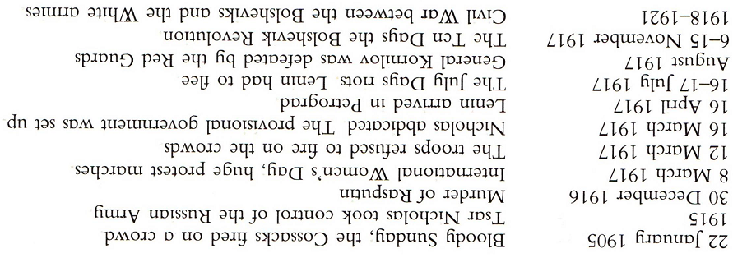

Task Two
1. The historian John Traynor (1991) identified NINE features which mark a ‘typical revolution’:
Looking at the events of 1917, discuss in a small group or as a whole class:
- was the ‘March Revolution’ actually a proper ‘revolution’?
- how many ‘revolutions’ were there in 1917 (historians’ answers range from one to four)?

Task Three
1. EITHER: write a narrative account of ‘The Year 1917 in Russia’
OR: do the (difficult) worksheet R16: ‘Find the Celebrity!’

THE CORRECT ANSWERS ARE:
