Put the title Poster Propaganda into your exercise book.

Study the information on the webpage, then:

Task One
1. Working in a small group or as a whole class, discuss and analyse the ten posters.
- Who was it aimed at?
- How was it trying to influence them?
Having studied the posters, which do you think was the most powerful:
2. Do ANY of the posters show reality of war as described in Dulce et Decorum? Why?
3. One of the posters was disliked by the government – can you suggest which (and why)?

POSSIBLE ANSWERS TO THE ANALYSIS OF THE POSTERS:
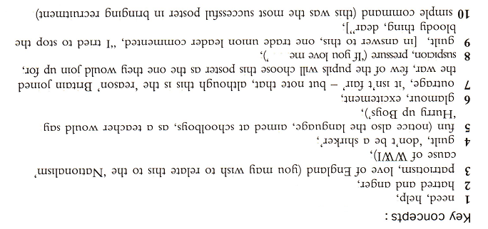

POSTER THE GOVERNMENT DISLIKED:
