Put the title Long-term Causes of WWI into your exercise book.

Note that these tasks cover two webpages – the webpage on Europe in 1914, and the webpage on Long-term Causes of the First World War.

Study the information on the webpage, then:

Task One – using the webpage on Europe in 1914
1. Working as a whole class, discuss the meaning and symbolism of the cartoon-map, viz:
- Looking at the faces of Austria-Hungary and Germany, were the Germans afraid of their enemies ranged against them?
- Looking at the faces of Britain, France and Russia, which country was Germany most afraid of? How can you tell?
- Interpret the meaning of: The iron fist striking Britain from the sea; Zeppelins over Britain and in the mouth of the Russian; The bees coming from the German hive; The Japanese navy tied to Britain; The Irish trying to cut their tie to Britain; The Austro-Hungarian soldier pointing his rifle at Russia; Belgium is represented as a toad.
- This is a German cartoon-map; looking at it as a whole, would you say it shows that Germany was 'on the 'defensive', or 'on the offensive', in 1914?
2. Use the cartoon-map to complete the map of Europe in 1914, worksheet CF1. Colour in the Triple Entente and the Triple Alliance. Explain to a partner why Germany felt threatened by the Triple Entente.

Task Two – using both webpages
1. Complete worksheet CF2: Causes of World War One.
2. Write the words ‘Nationalism’, ‘Imperialism’, ‘Militarism’ and ‘Alliances’ in the four corners of a piece of paper, as here:
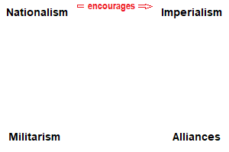
Note the connecting ‘encourages’ line – nationalism encourages imperialism because a country that thinks it is superior to other countries will think it has the right to conquer and control them.
Working with a partner or in a small group, see if you can add any more ‘encourages’ lines (with full explanations of HOW it encourages it) onto your diagram – how many can you realistically add (there are eleven possibilities).

