Put the title The British Empire – wanted and won in your exercise book.

Read the information on the webpage, then:

Task One:
1. Working with a partner or in a small group, study the Introduction. It tells the story of the growth of the British Empire but, in amongst the story, try to find TEN reasons why the British wanted an Empire.
2. Working with your partner or small group, revisit the Introduction. Now try to find, in amongst the story, TEN reasons why the British won an Empire.
3. Working alone, do the British Empire Wordsearch so as to find all 20 factors in the growth of the British Empire. Did you find all twenty?
Sort the list into those ten reasons which help us understand why the British wanted an Empire, and those ten reasons which help us understand why the British won an Empire.

Task Two:
1. Sheets E1i-ii sum up the ten reasons why the British wanted an Empire.
You will find that you can run them off on your printer double-sided (or print them single-sided and stick the explanations onto the back of the titles. Do so to make a set of ten cards.
Working in a small group or as a whole class, FIRST, place the cards in a pile, with the explanation face up. Taking turns, read the explanation and try to guess which reason it is referring to. Then check your answer against the back of the card. If correct, you keep the card, if wrong, the card is put at the bottom of the pile. The group member with the most cards wins
NEXT, place the cards in a pile with the reason face up. This time take it in turns to try to explain how the reason on the card worked to cause Britain to want an empire. Again, check your answer against the explanation on the back of the card. If correct, you keep the card, if wrong, the card is put at the bottom of the pile. The group member with the most cards wins.
FINALLY, place the cards in a suggested order of importance, discussing the reasons for your choice of order.
2. Sheets E2i-ii sum up the ten reasons why Britain WON an Empire. Repeat step 2 for this issue.
3. Write an essay of 500 words (i.e. c. 50 words per reason) explaining EITHER: ‘Why did Britain want to gain an empire?’ OR ‘Why was Britain able to win an empire?’
Remember to PEE every paragraph:
- Make the Point simply
- Cite your facts and Evidence
- Explain how it caused the effect.
Finish with a conclusion pulling all the ideas together.

ANSWERS TO THE WORDSEARCH
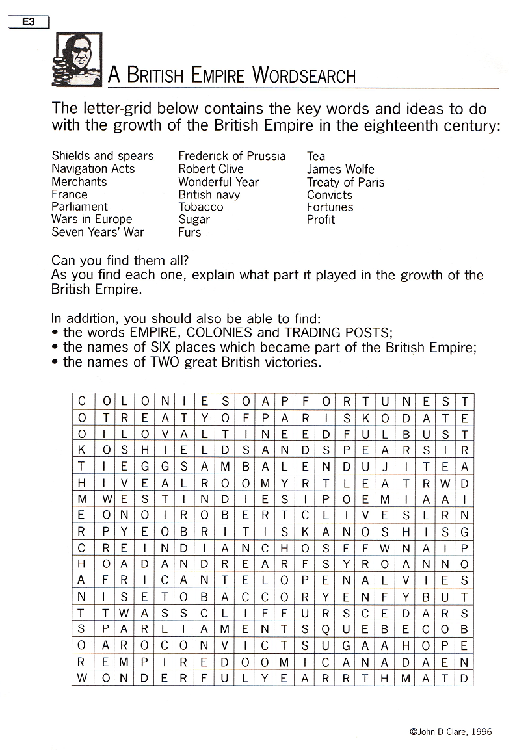
Cardsheet E1i

Cardsheet E1ii
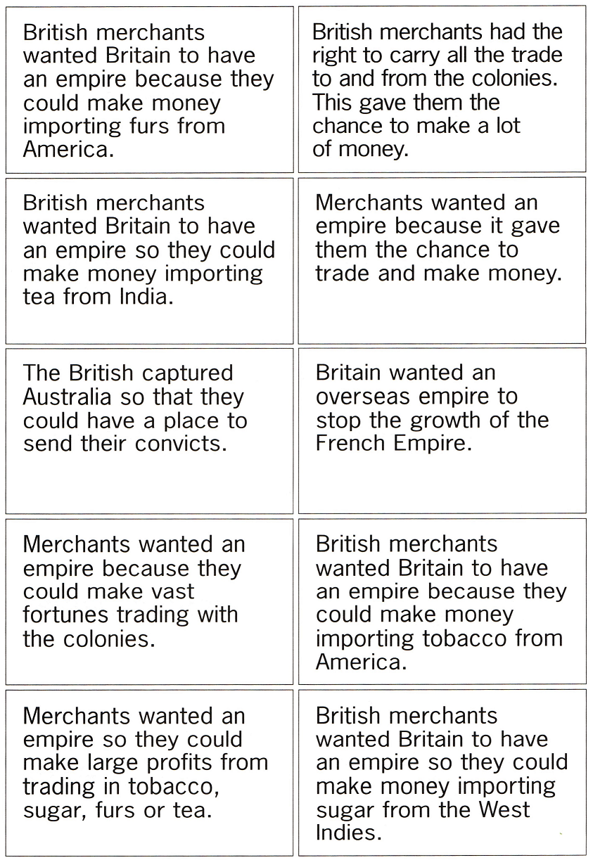
Cardsheet E2i
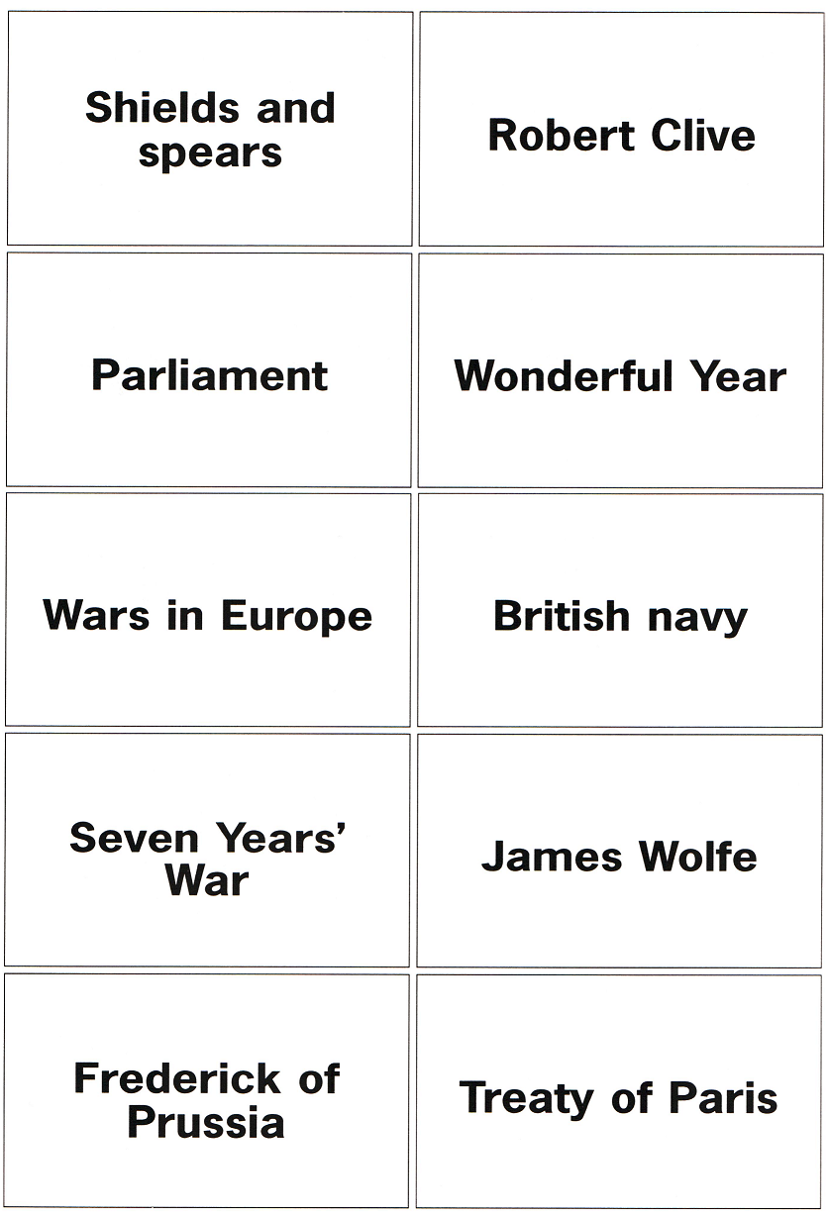
Cardsheet E2ii
