Put the title An Age of Change in your exercise book.

Read the information on the webpage, then:

Task One:
1. Working alone, study the pictures and text in the Introduction. Then make notes on the changes which occurred during the 19th century, under the following headings:
- From Small Kingdom To Worldwide Empire
- From 7 Million To 41 Million People
- From Villages To Cities
- From Farming To Industry
- From Domestic System To Factories
- From Muscle To Machinery
- From Wagons To Steam Trains
- From Poverty To Reform
2. Working with a partner or in a small group, study Source 1. What differences do you notice between Sydney Smith’s description of the changes, and the description of the changes in the Introduction?

Task Two:
1. Complete the worksheet: ‘The World We Have Lost’. Colour the pictures if you wish! Working with a partner or in a small group, discuss what changes the two pictures illustrate.
2. Discuss as a whole class:
One historian called the years before 1750: 'The world we have lost.'
Were all the changes of the period 1750-1914 changes for the better??
3. Write 400 words beginning: ‘Nineteenth century England was an age of change…’

The World We Have Lost
This picture shows the inside of the cottage in 1846:
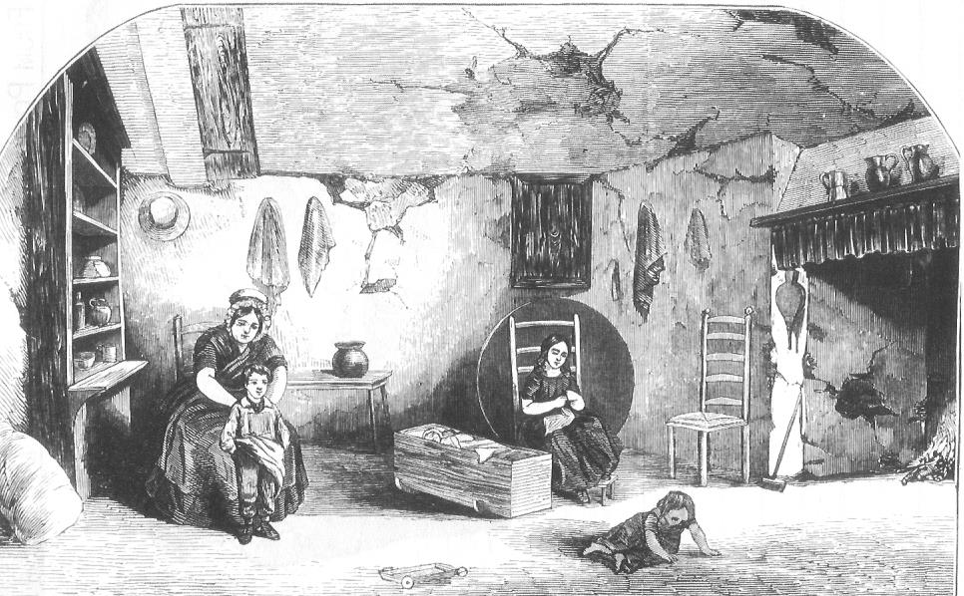
Draw here a picture of your front room, so as to emphasise the differences:

