Civil Warfare … or Why Cromwell Won

Army commanders in the Civil War still fought 'pitched' battles, which meant that the time and the place were arranged beforehand. The two sides organised their forces in battle lines, facing each other.
They put the infantry (foot soldiers – pikemen and musketeers) in the centre of the line. The cavalry (soldiers on horseback) were put on the flanks (sides) of the army. The armies charged at each other.
But whether the battle was won or lost depended on the cavalry. For the king, Prince Rupert was a brave cavalry commander. He and his men made a wild charge which almost always drove his opponents from the field. But his regiment became separated during the charge, and then he often forgot about the battle and chased the enemy for miles.
Cromwell was as brave as Prince Rupert but his troops were better disciplined. They advanced at a trot. So when Cromwell defeated the enemy cavalry, he was able to swing round and crush the enemy infantry. The difference between Rupert and Cromwell helps to explain why Parliament won the Civil War.

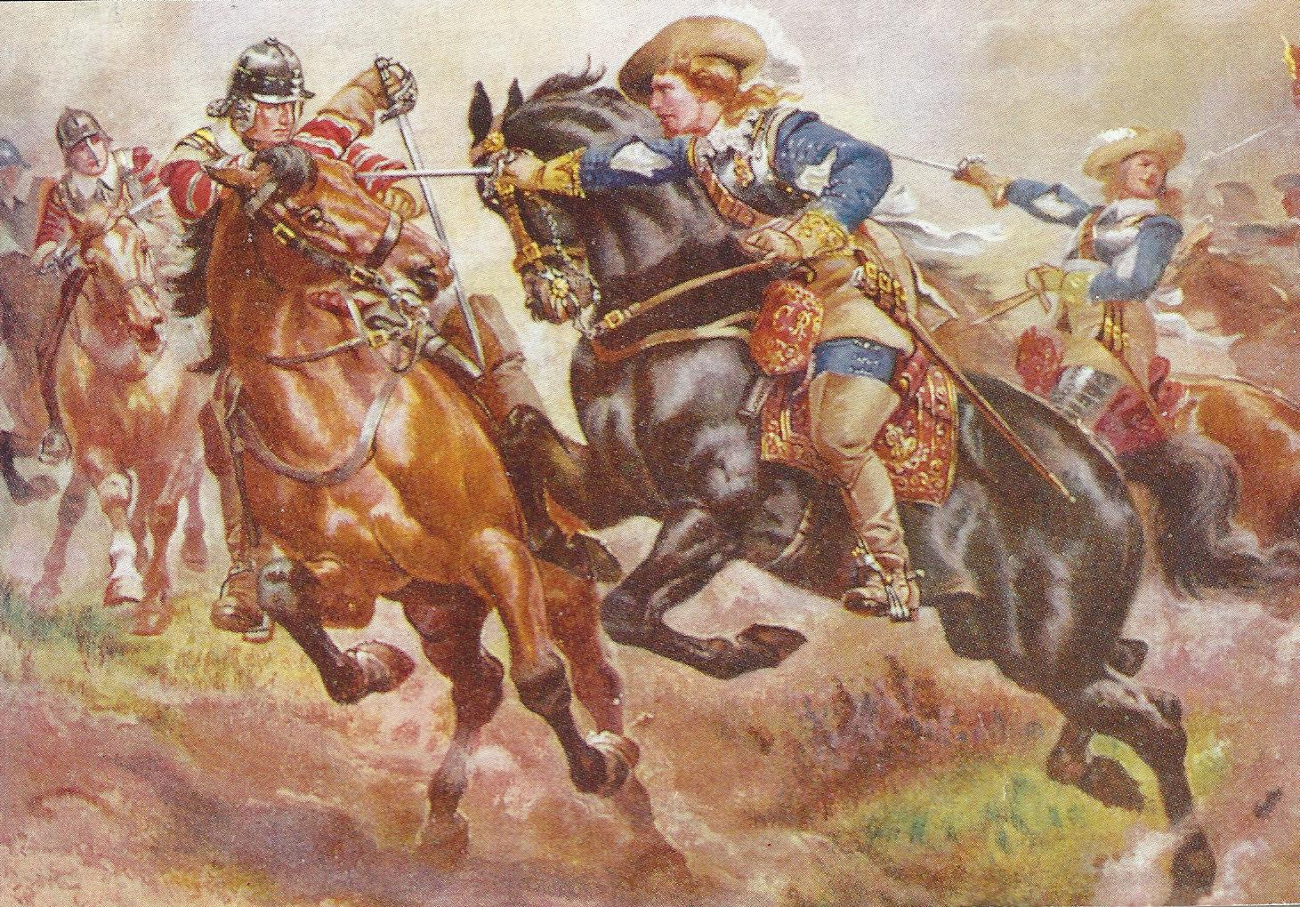
Cavalry Cavalry troopers fought on horseback using swords and pistols. They rarely wore armour , but for protection they wore a 'buff' coat made of thick leather.

