Put the title Farm Workers in your exercise book.

Read the information on the webpage, then:

Task One
1. Working with a partner or in a small group, study and discuss Source 1 and:
- make close notes on what you see in the picture – what work is being done, what tools are they using, what are they wearing, what were the most important buildings in the village etc.
- suggest five words which sum up/describe the life of the people in this picture; what was their life like
- do you think this painting gives a reliable impression of agricultural life and work?
2. Still working as a small group, study and discuss Source 2 and use the account to work out 'a ploughman's day' to do the worksheet: ‘A Farm Labourer’s Day’.
- suggest five words which sum up/describe Markham’s portrayal of a ploughman’s life
- do you think this source gives a valid impression of a ploughman’s life; suggest FIVE reasons why it cannot.

Review everything you have learned about everyday life from webpages in Chapter 2. Think about what you have learned about the standard (wealth, possessions etc.) and quality (happiness, comfort) of life in Early Modern times:

Task One
1. Coming together as a whole class, hold a plenary session to collect ideas. What is your overall judgement on the standard and quality of life – or men and women – in Early Modern times (remember to support your opinions with facts and evidence).
2. Compare everyday life in the Early Modern Age with everyday life today. When would you prefer to live … and why?

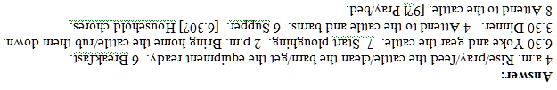
A Ploughman’s Day
§A First complete the table below, using source 2 on the webpage.

 | Rise/pray/feed cattle/clean barn/get equipment ready.
6.00
 | Yoke and gear the cattle.
7.00
 | Bring home cattle/rub them down.
3.30
 | Attend to the cattle and barns.
6.30 | Household chores.
8.00
9.00

§B Then use the grid below to do a timeline of your own day on the left, set against a timeline of a ploughman's day in 1653 on the right.
My Day A Ploughman’s Day
12
1
2
3
4
5
6
7
8
9
10
11
Noon
1
2
3
4
5
6
7
8
9
10
11
12

