Put the title Were Medieval Towns Dirty? in your exercise book.

Spend some time carefully reading/studying all the information on the webpage.

Task One
1. Working with a partner or in a small group, discuss Source 1. What impression does it give of life in a medieval town? What kind of things happened in a medieval town? (When you have finished looking for yourself, if you want to cheat, there is a crib-list of scenes on the fact-sheet ‘Dirty Old Town – List of Scenes’.)
Considering, how true to life do you think it is of everyday life in a medieval town?
How would life in your town appear if you made a judgement based ONLY on court-cases?

Task Two
1. Working with a partner or in a small group, study and discuss the following issues.
- Read Sources 3 and 4. List all the ways they support/agree with Source 1?
- Source 4 makes seven statements; what are they? Divide the statements into facts and opinions.
- In Source 4, Hartley suggests a reason why people behaved in an unhealthy way. What reason does he suggest? Explain in your own words how this would have led people to behave in an unhealthy way.
- Read Sources 5, 6 and 7. What impression do they give of medieval towns? They are both Primary sources (sources from the time) – do you think this makes them more trustworthy, or less trustworthy as a source?
- List all the statements you can find in Sources 2-7 which suggest medieval towns were dirty.
2. At this point in your study, would you be prepared to make an interim suggestion about whether medieval towns were clean or dirty? What would your interim conclusion be (remember that you can change it later)?

Task Three
1. Working with a partner or in a small group, study and discuss the following issues.
- Read again Source 5. It is a law-case brought against a person who was dirtying the town. Does this source really prove that medieval people were dirty?
- Read again Source 6. It is a law enforcing standards of sanitation. Again, does this source really prove that medieval people were dirty?
- Read again Source 7. Look at the date. Again, does this source prove that medieval people were dirty?
2. Distinguish between the primary sources (from the time) and the secondary sources (written or drawn many years later). Identify a primary source which would be cited:
- by an historian who wanted to prove that public health was poor in late medieval towns;
- by an historian who wanted to prove that public health was good in late medieval towns.
3. Go through Sources 2-7. Discard secondary sources which claim medieval towns were dirty, but provide no facts to back up their claim. Can you find ANY source which proves that medieval towns were dirty?
4. Study Sources 8-10. List all the FACTS you can find which suggest that medieval towns were NOT so dirty.
Task Four
1. Working with a partner or in a small group, study the question in a different way. Taking each of these issues in turn, discuss whether medieval towns were as dirty as Moss and Hartley suggest, or cleaner:
- water supplies,
- baths,
- sewage and refuse,
- housing
Has looking at the question in this way helped you formulate your considered opinion?
2. As a whole class, debate the statement:
‘Norman Meredith's drawing (Source 2) gives a completely misleading picture
of public health in late medieval Britain?
3. Write an essay:
‘How true a picture of public health in late medieval Britain
does Norman Meredith's drawing (Source 2) give?
To write your essay:
- Start by writing: ‘Many historians assume that medieval public health and hygiene was bad.’ Then develop this idea, explaining what they claim, and what evidence and arguments they use to support their claim.
- Next, write: ‘However, some historians suggest that medieval public health and hygiene was bad.’ Then develop this idea, explaining what they claim, and what evidence and arguments they use to support their claim.
- Finally, write: ‘In conclusion therefore…’ and say what YOU believe, backing up your idea with evidence and arguments.

Dirty Old Town – List of Scenes
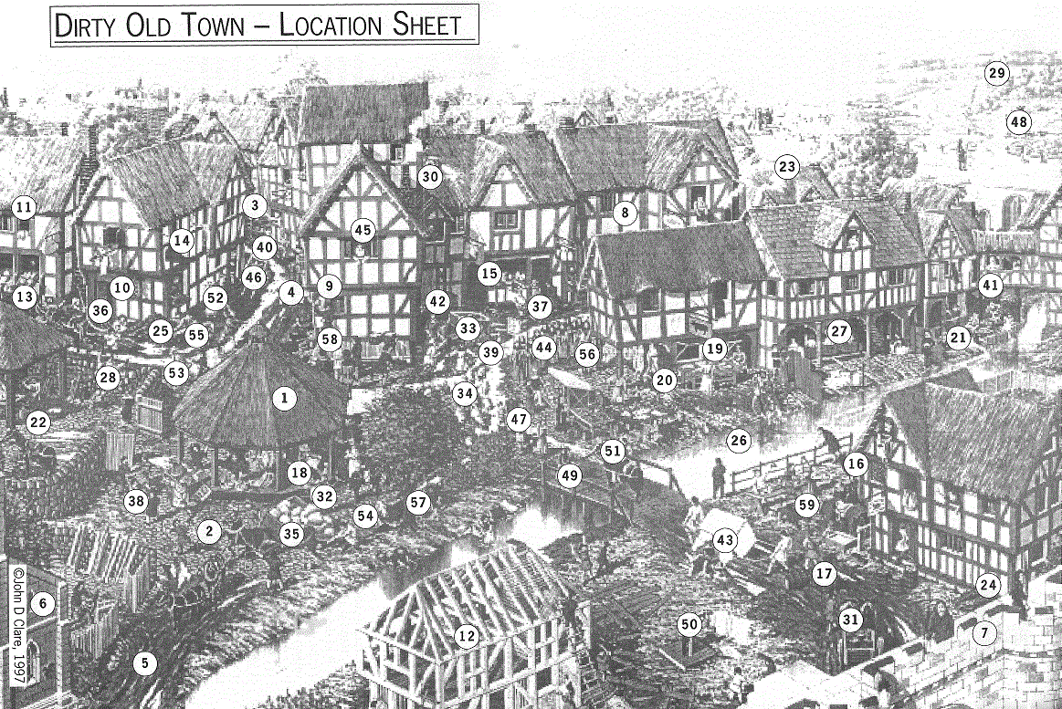
Dirty Old Town – List of Scenes

Places of note
1 The market square,
2 which is cobbled.
3 Narrow streets leading off the square; they are just muddy tracks with
4 a central gutter, full of filth.
5 The surface of the streets is torn up and broken.
6 The church, which is the only stone building (apart from the castle).
7 The town walls.
8 The houses are half-timbered,
9 with oversailing (the upper storey juts out over the one below)
10 and small-paned windows
11 with sliding shutters.
12 One house is being built.
13 Shops — look for the baker and the shoemaker;
14 they have huge signs (loaf, shoe),
15 with a counter, open to the street.
16 An ale house, with a large bush (bunch of branches) outside;
17 there are also a large number of barrels outside, blocking the traffic.
18 Some stalls (e.g., draper).
19 A butcher's shop; the blood runs down the gutter into the stream.
20 The butcher has a huge pair of weighing scales.
21 A dyer, emptying his vats into the stream.
22 A blacksmith's yard (called the Woodyard' — note the piles of wood around) with a smithy.
23 Lots of smoke from chimneys (burning wood, not coal — so the smoke is white, not black) and the blacksmith's.
24 Dung heaps and rubbish heaps outside houses and in the streets.
25 The public well in the square; the water is filthy, but a woman is filling a bucket from it.
26 A filthy stream, full of garbage and dung – people are urinating and being sick into it, a woman is doing her washing in it and a poor woman is taking water from it.
27 The public baths ('stewes'), which are places of immorality.
28 One wall in poor repair is falling down on the children playing beside it.
29 In the background, note the windmills.

Things happening
30 People are emptying urine and throwing rubbish into the streets from upstairs windows.
31 There is a lot of traffic,
32 with some packhorses and
33 a few hand-carts.
34 Country people are driving sheep through the market place.
35 A cart axle has broken, and the cart has toppled over, crushing a woman. The cart had three horses. The carter is running away, frightened that he will be killed or beaten up.
36 Two men on horseback are passing too near to a woman carrying a baby; a man is shouting at one of the riders, who is about to stab him with a long knife.
37 Three men (two shopkeepers and a street-seller) are quarrelling about a pile of eel-skins that the street-seller has dropped outside a shop; one of the shopkeepers is giving the eel-seller a fatal blow on the ear with his fist.
38 Half a dozen men are quarrelling over a basket of apples; one is hitting another with a quarterstaff.
39 A thief has been spotted and is running away – a hue and cry has been raised 'by horn and by voice', and a man is running after him (he has drawn his knife).
40 A gang of boys are rolling a barrel full of stones down the street `to the great terror of the neighbours'.
41 A set of open privies has been built OVER the thoroughfare, and the excrement is falling onto the heads of the passers-by.
42 A ‘gongfermer’ is digging the excrement out of a cesspit and loading it into a cart.
43 A wealthy woman has fallen off a sedan chair into the mud, to the amusement of the passers-by.
44 A church procession to ward off the plague is passing down the street.
45 Pretty girls are hanging out of upstairs windows, watching the proceedings.
46 A plague cart is collecting dead bodies.
47 Some people are carrying a coffin.
48 Outside the town, carts take bodies to huge pits.

People and animals
49 Beggars.
50 A man in the pillory/stocks: people are throwing rotten vegetables at him.
51 Rich people – 'delectable lusty ladies bright, famous bishops in habits clerical, and merchants of substance and might'.
52 Many of the rich people are holding oranges or posies over their noses (because the poor people smell).
53 A street-seller calling out his wares.
54 Pigs eating the refuse in the street.
55 Dogs roaming the streets.
56 Outside some houses a woman is spinning.
57 Children playing games – e.g., swinging on a tree, stoning the crows (and breaking the church windows).
58 A town crier shouting out announcements ('oyez').
59 Many drunken people.

