Put the title The Perfect Gentle Knight in your exercise book.

Task One
Working with a partner or in a small group, study the Introduction and Sources 1-5
1. Compile a list of attributes which characterised the ‘chivalry’ of a good knight.
2. Find connections between the different sources – similarities and differences. Does the fact that two sources agree make what you have discovered any more reliable/trustworthy/true?
3. From what you have learned and nothing else, how accurate an interpretation of a medieval knight would Jan Struther’s schoolchildren’s hymn appear to be?
4. Discuss as a group why – despite all the evidence – one might nevertheless doubt that medieval knights were paragons of virtue.

Task Two
Working on your own:
1. Study the picture-sheet: ‘The Knight in Battle’.
2. Complete the worksheet: ‘The Knight in Battle: Questions’.
3. If you want, just for a bit of fun, you can construct the cut-out: ‘A Knight in the Middle Ages’ … but you should realise that this exercise has no historical validity whatsoever!

Task Three
Working with a partner in a group, study Source 6:
1. This poem is beautiful and wistful. Discuss it in your group, especially:
- How does Arnaut feel about his lady-love?
- What do the last three lines mean?
- Choose your favourite lines/sentence/phrase and explain why to the rest of the group.
2. The idea of ‘courtly love’ jars with our modern idea of the ‘perfect gentle knight’ – we would not regard it today as a good thing to try to seduce someone else’s wife. Speculate as why this was acceptable in the Middle Ages. Share your suggestions with other groups.
3. If you have the opportunity, do further research into (one of) these aspects of the knight’s life:
- Courtly love
- Jousting
- How a man became a knight
- Minstrel-knights
- Heraldry and coats of arms
The Knight in Battle
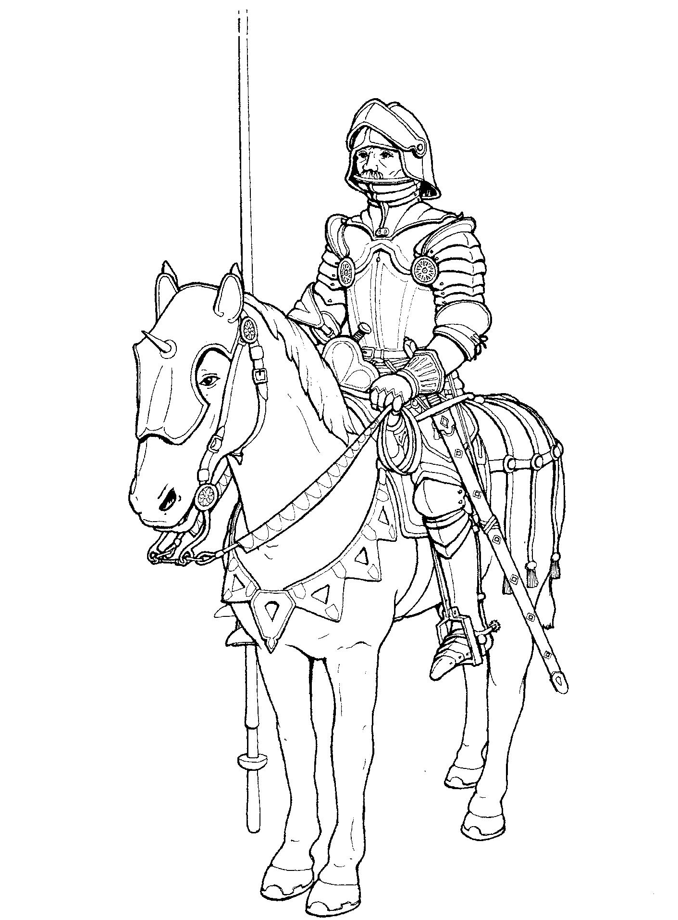
His lance.
His suit of armour weighed about 25 kilograms.
His armour was made up of a series of hinged metal plates, which allowed him to move.
If he fell off his horse he could get up easily.
Under his armour, he wore a padded doublet.
This protected him from blows to his body.
His sword.
His stirrups.
His spurs were a sign of his knighthood.
Strips of blanket were tied round his knees to stop the armour rubbing.
His reins.
Cavalry horses were specially bred and trained to carry the knights.
A bevor protected his chin. (The word ‘bevor' comes from the French word bevoir, meaning 'to dribble'.)
He could raise the visor of his helm, so he could see more easily.
The Knight in Battle: Questions
Answer the following questions using the picture-sheet 'The Knight in Battle’.

1. How much did a suit of armour weigh? ………………………
2. What piece of armour protected his chin? …………………….
3. What did he wear under his armour? ………………………….
4. Which two weapons did he carry? …………………………….
5. What did he tie round his knees? ………………………………
6. How did he control his horse? …………………………………
7. Where did he put his feet? ……………………………………..
8. What was the proper name for his helmet? …………………….
9. Why would he raise his visor? …………………………………
10. Why was he able to move in his plate armour? ……………….
………………………………………………………………….

When you have answered these questions, draw a line from each label to the correct part of the drawing.
A Knight in the Middle Ages
