Put the title The Crusades in your exercise book.

§1 - The story of the Crusades
Study the Introduction and Sources 1, 2 and 3.
Task One
Working with a partner or in a small group:
1. Go through the events of the ‘Story of the Crusades’ in turn, giving the crusaders a mark out of ten for their success in each event (for example, you might score the capture of Jerusalem in 1096-99 as a 10, but the fall of Constantinople in 1453 as a 0).
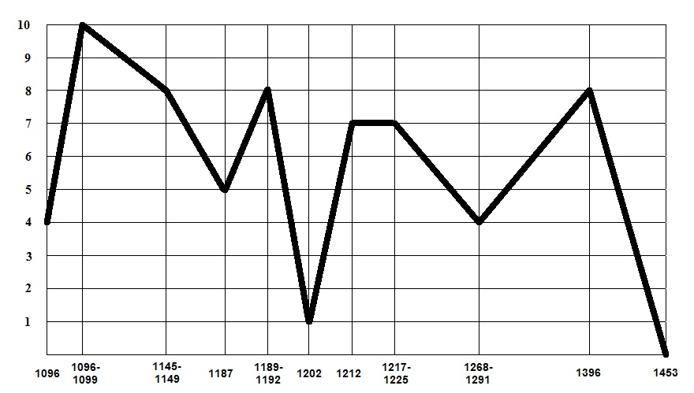
Fill in your scores on the ‘Ups and Downs of the Crusades’ graph, to create a line graph – e.g.:
Compare you graph to the graphs of other groups, and discuss the differences.
Looking at the Crusades as a whole, were they overall a success or a failure?
2. Discuss Source 1. What impression does it give of Richard the Lionheart and his motives?
- Do you think that Muslim writers would have felt the same way about him?
Repeat for Source 2.
3. Now study Source 3. How is it different from Sources 1 and 2? Which – given what you know – do you think offers the more realistic interpretation of what the Crusades were really like?

§2 - Why did People Go on Crusade?
Study the section ‘Why go on Crusade?’
Task Three
Working with a partner or in a small group:
1. Make a list of all the reasons you can find why different people went on Crusade: for each reason.
2. Suggest what kind of people would have been motivated by that reason to go on a Crusade (if you want, you can use the worksheet ‘Crusaders’ to help you.
3. Explain carefully HOW the reason would have motivated them to go on Crusade.

§3 - Results of the Crusades
Study the section ‘Results of the Crusades’.
Task Four
Working as a whole class:
1. Find FIFTEEN new things that became known in the West as a results of the Crusades.
2. Discuss the idea: ‘the Crusades changed the world’.
3. Discuss the idea that the Crusades were an unjustified war and should never have been undertaken.

The Ups and Downs of the Crusades

Crusaders – Becoming a crusader

When Pope Urban called for a crusade, he asked kings, nobles and knights to take part in it. Bishops and priests travelled around the country calling men to join in the holy war. They were very successful. All kinds of people from kings to beggars rushed to 'take the cross'.

Here is a list of reasons why people went on crusade:

1 To obey the Pope's call
2 To help Christianity grow
3 To be forgiven for sins
4 To kill and steal
5 To have an adventure
6 To see the Holy Land
7 To bring back new goods
8 To prove their bravery
9 To get land overseas
10 To earn freedom

1. Look at the list of people below. Put them next to the most likely reason for them to join a crusade. They can go next to more than one reason.
King
Knight
Villein
Trader
Priest

2. Draw a cross (+) next to all the religious reasons.

3. Study the reasons (1-10 above) which caused people to go on crusade. Which do you think was the most important?

