Put the title The Battle of Hastings in your exercise book.

§1 - Sequence
Read the Introduction on the Battle of Hastings, and study Sources 1-3.

Task One
Working with a partner or in a small group:
1. Discuss at which point in the story the three sources would best be placed as an illustration.
2. Do the worksheet ‘Battle of Hastings – Sequencing’ – see if you can put the events of the battle in the correct order without having to refer to my story.

* * *

§2 - Opinion
My account of the Battle of Hastings in the Introduction includes things where I have used my own judgement, and added ‘colour’ to make the story exciting.

Task Two
1. Working in your group, do the worksheet ‘Battle of Hastings – Opinion’ to practise seeing the difference between bald fact, and embellished opinion. Can you turn some ‘opinions’ into ‘facts’ – for instance, by missing out certain words?
2. At this point, working on your own, use the information you have obtained to write up as purely factual an account as you can of the battle.

* * *

§3 - Presentation of information
The two worksheets ‘Hastings – Why Harold Lost’ provide 16 ideas as to why Harold lost the battle of Hastings.

Task Three
1. Divide the class into pairs – each pair takes a ‘reason’ why Harold lost.
2. Each pair discusses HOW that reason might have led to Harold’s defeat. They also consider how important a reason was – from ‘vitally significant’ to ‘of little or no consequence’.
3. Working as a class, draw a large target onto the board. Each pair in turn sticks their ‘reason’ onto the board – important reasons nearer the centre of the target, less important reasons nearer the edge (or off the target altogether). Discuss as a class each pair’s decision about their reason’s importance.
4. Working alone, write a piece: ‘Why Harold lost the Battle of Hastings’. As you describe the different reasons why Harold lost, explain HOW they contributed to his defeat, and how important you thing each was. Finish with a paragraph which sums up, for you, the overall cause of Harold’s failure.
Battle of Hastings – Sequencing

Put these sentences into the correct order:

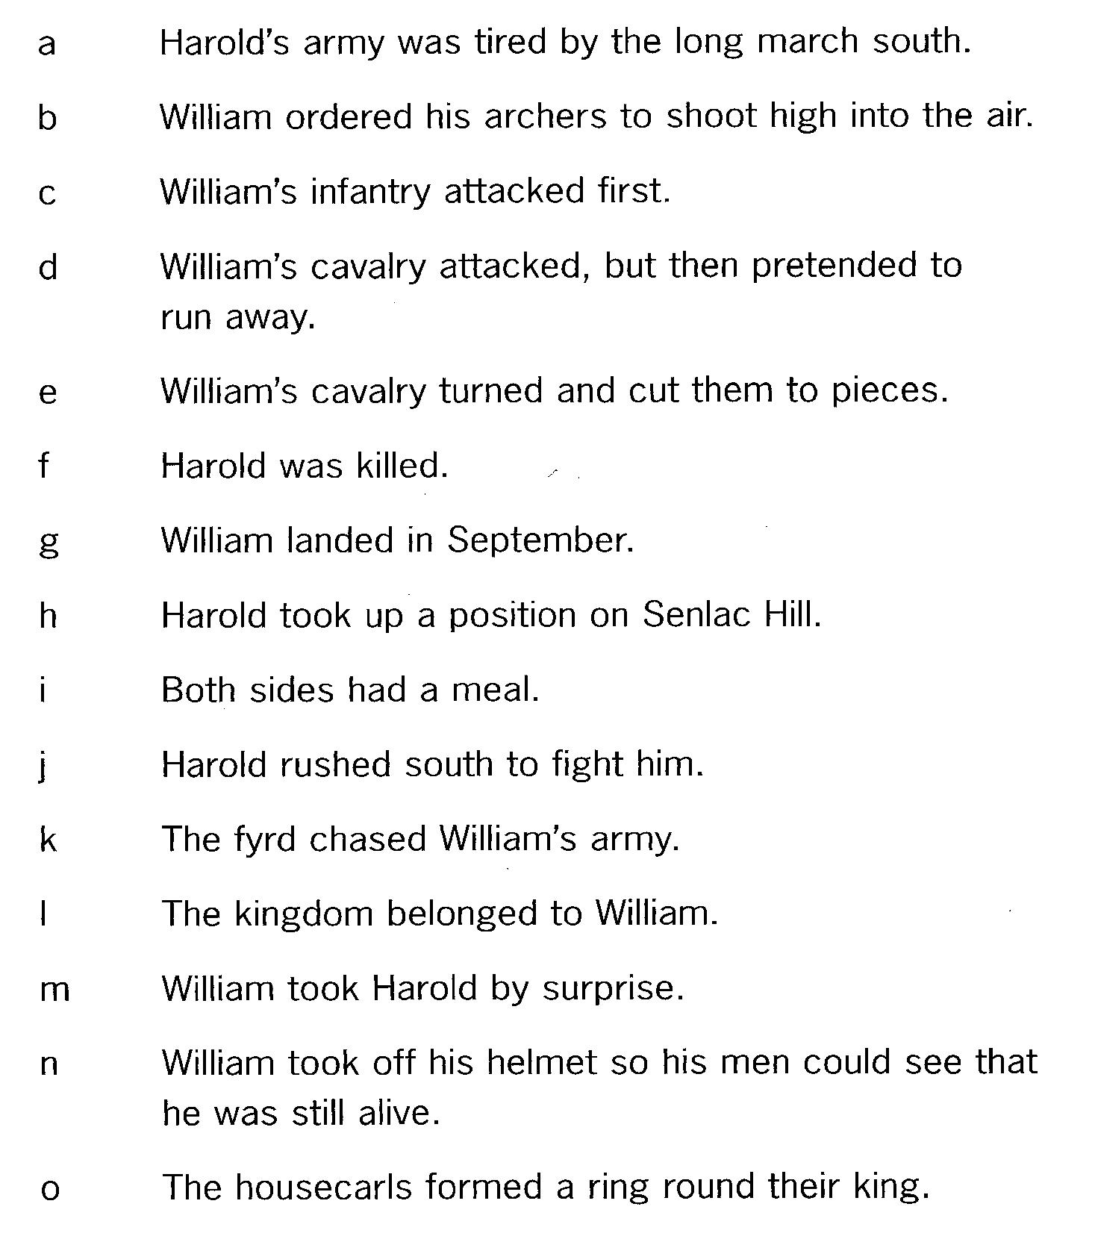
Battle of Hastings – Opinion

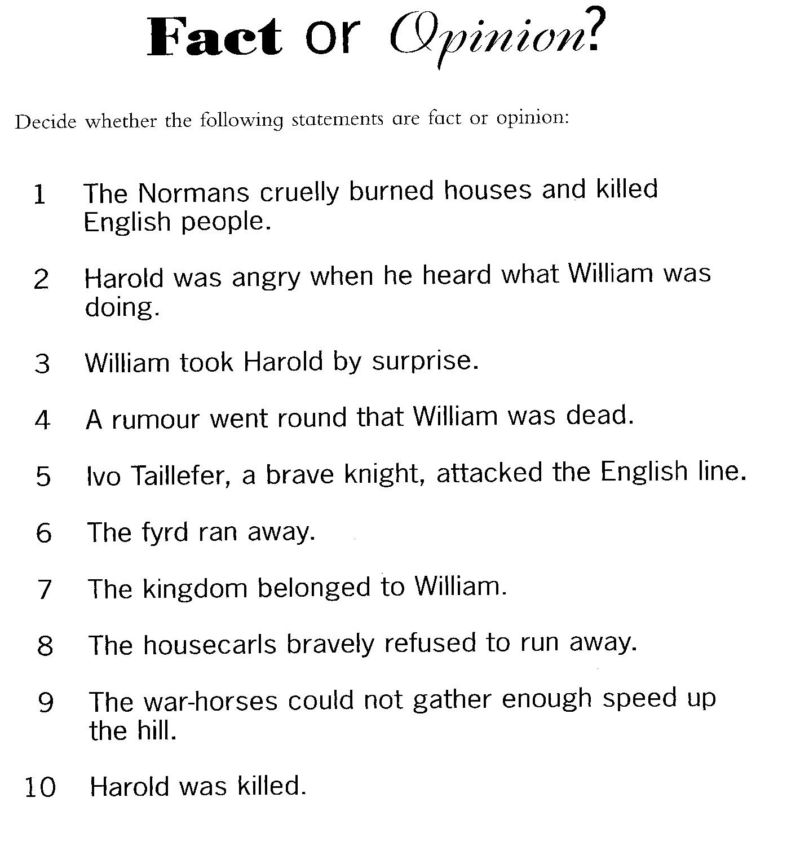
Hastings – Why Harold Lost: I
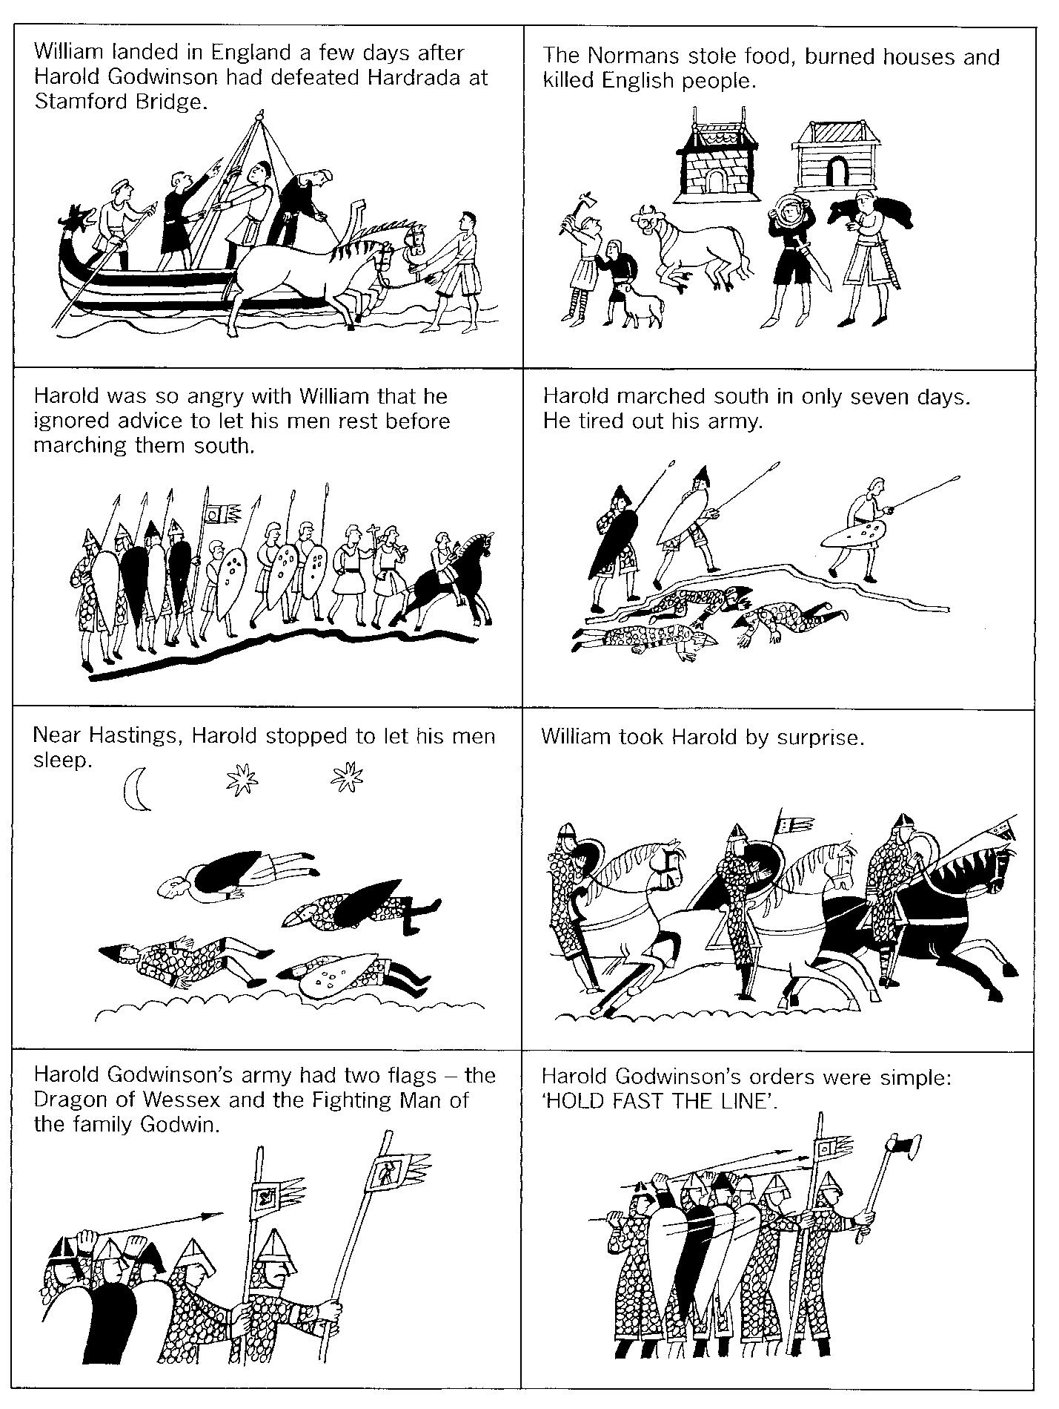
Hastings – Why Harold Lost: II
