2.8 The death of Alexander
We have two accounts of the death of Alexander to consider in detail.

Task 2H
Read the accounts of the death of Alexander given by Plutarch (Alexander 73-77) and Arrian (7.24-26)
- What sources were available to historians for their accounts of Alexander’s death?
- To what extent do these accounts agree?
- What do these accounts tell us about the relationship between Alexander, his companionsand the army?

There has been considerable speculation over the years about the cause of Alexander’s death. Years of campaigning must have taken its toll, together with the hardships of the journeys he undertook, such as the disastrous march through the Gedrosian Desert on his return from India: he had also received near fatal wounds on several occasions, as he himself told the troops at the time of the mutiny at Opis (Arrian 7.10). There are also references in the sources to prolonged drinking bouts, which certainly played a part in the death of Cleitus, though Arrian (7.29) considers Alexander’s drinking not to be significant:

As Aristobulus says, his drinking bouts were not long because of the wine, as Alexander drank little wine, but because of his friendship with his companions.

Plutarch (Alexander 77) discusses the idea that the king was poisoned, which he says the majority of historians dismiss. Neither Arrian nor Diodorus support the case for poisoning, and the historian Robin Lane Fox argues that the length of time Alexander was ill is a strong argument against the use of poison.

2.9 The Successors of Alexander: Alexander’s body
The death of Alexander precipitated a crisis within the Macedonian elite. His only gesture towards appointing a successor as he lay ill was the handing of his signet ring to Perdiccas. As his body ‘lay unattended in a stifling hot place’ (Plutarch, Alexander 77), some of his companions began to manoeuvre themselves into positions to secure some or all of Alexander’s conquests for themselves. In the immediate aftermath, there were a number of principal contenders and there was the threat of a split between the members of the elite officer class and the infantry, who remained loyal to the royal house of Macedon and demanded that Arrhidaeus, an older half-brother of Alexander, be named as king, despite his apparent mental weakness. A compromise was reached whereby Arrhidaeus was renamed Philip and accepted by the army as king (jointly with the as yet unborn child of Roxane, Alexander’s wife), with Perdiccas as regent. Antipater and Craterus were also prominent in the new arrangements. This agreement was reached in the presence of Alexander’s dead body.

The army were given the opportunity to hear and reject Alexander’s plans for further expansion of the empire and major building projects in honour of the gods, his father Philip and Hephaestion (Diodorus 18.4). It is very possible that these so-called plans were exaggerated by Perdiccas or others to ensure that they would be rejected by the rank and file of the army.

Although Perdiccas emerged as the most powerful figure in Babylon, there were other important figures whose views about the future would be important. Antipater remained in Macedonia with a powerful army; Craterus had been sent to replace with him by Alexander but was in Cilicia with some 10000 veterans; there was also Antigonus One-Eye at Celaenae. Within a few months, Roxane gave birth to a strong male child, who was acclaimed by the army as Alexander IV.

In a relatively short time, the empire created by the will of one man began to fragment. One question that had to be settled was what to do with the body of Alexander. It was agreed by the Macdonian leadership at Babylon that he should be embalmed and then taken to Ammon’s sanctuary at Siwah to be buried. However by the time the arrangements for transporting the dead king in due pomp were completed two years later, Perdiccas tried to get the body transported to Macedonia so that Alexander could be buried in the traditional resting place of Macedonian kings at Aegae. However Ptolemy managed to intercept the funeral cortege at Damascus, and took the king’s body back to Egypt. He first buried him at Memphis and then installed him in a magnificent tomb in Alexandria.

The importance of Alexander to his successors is clear from the way their service with him is regularly used to strengthen their claim to authority. Coins continued to be issued with Alexander’s name on them after his death; Ptolemy was the first to introduce new coins, showing Alexander wearing an elephant scalp headdress together with the ram’s horns of Ammon; much later, he issued coins as king with his own portrait on one side and Alexander on a chariot drawn by elephants on the other. Seleucus followed very much the same pattern in Babylon. Lysimachus, originally awarded the satrapy of Thrace, managed to profit from the fighting in the years after Alexander’s death, and gained control of Asia Minor; he too struck coins with Alexander’s image.

Ptolemy’s coinage Picture Source:
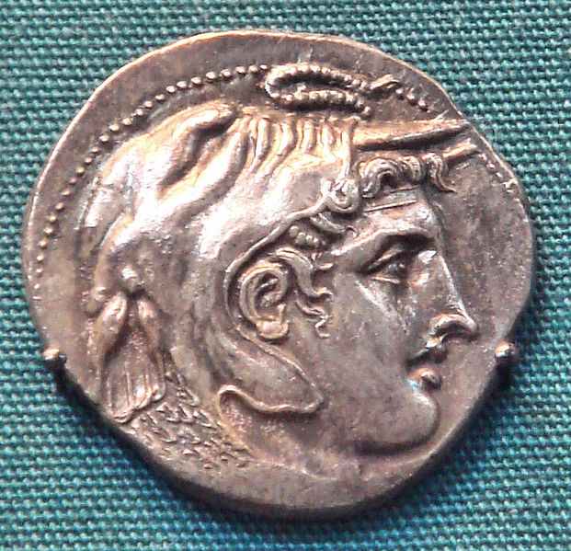
Lysimachus’ coinage Picture Source:

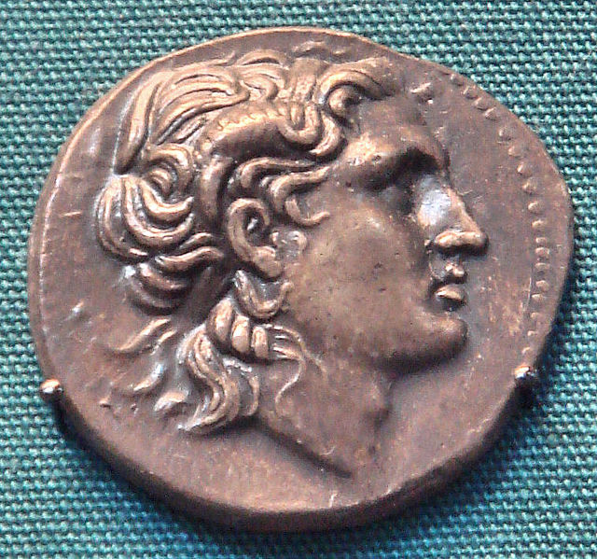

3.14 Alexander’s Legacy

Alexander’s achievements had a considerable impact on his own times, and after his death, the break-up of his empire drew a new map for the future development of the areas he had conquered. The ruling families founded by his companions, such as Ptolemy in Egypt or Seleucus in Babylonia, had a lasting impact on the ruling elites in those areas. Arguably just as important for the spread of Greek influence through the vast areas conquered were the various cities he founded (or refounded): Plutarch (On the Fortune of Alexander 1.5) claims he established ‘more than seventy’, but this is clearly an exaggeration; there may have been as few as eight cities called Alexandria in various parts of the empire, and a larger number of other towns transformed in some way by Alexander’s passing (and in later years at least eager to claim an association with the great man).

Many of these cities were set in strategically important sites: Alexandria on the coast in Egypt at one end of the empire; Alexandria Eschate to the north in Sogdiana; Alexandria on the Hyphasis in the east. The cities were founded for mixed populations: Alexander left behind those of his forces who were not fit to fight any further or whom he no longer trusted, but there were also natives of the region. The effect of the dispersion of Greek culture through the empire helped hold it together over time.

Not all the Greeks and Macedonians settled in this way were happy to be so far from their homeland. There were attempts by the mercenaries settled in Alexandria Eschate to return to Greece, but these were bloodily suppressed.

The most famous of these cities was Alexandria in Egypt, where Ptolemy transformed his satrapy into an empire. Although he originally buried Alexander’s body at Memphis, he later brought it to Alexandria which developed into a major centre of Greek culture over the next few centuries. It was developed by the Ptolemaic dynasty as the capital of Egypt and a major port. The Tomb of Alexander was a major attraction, as was the famous library.

